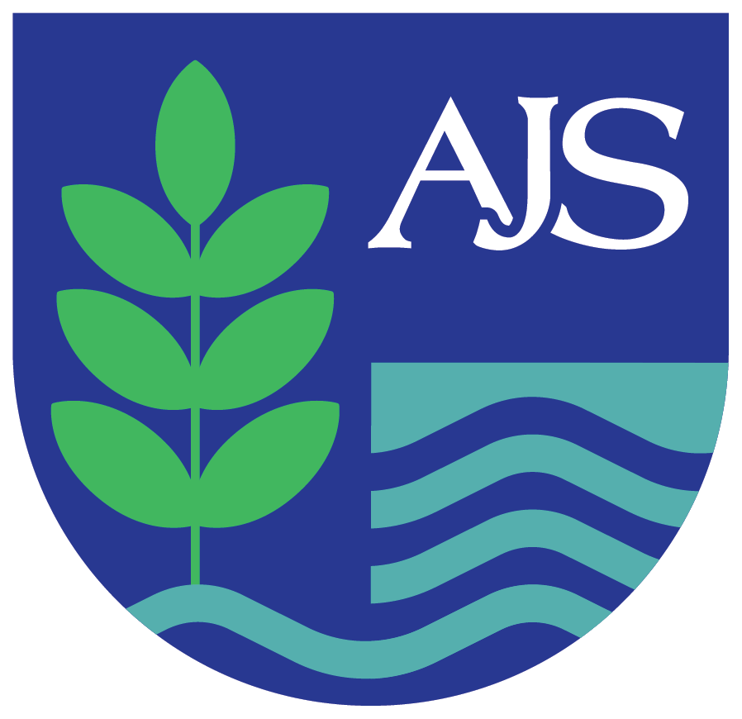

Public Sector Equality Duty (PSED)
Statement and Objectives
2025

Author | Publication Date | Review Cycle
Heather Tarrant Executive Headteacher | September 2025 | Annually

School Vision
At Ashbrook Junior School, we nurture ambitious, compassionate, and confident learners who are ready to make a positive difference in their community and the wider world.
We believe that confident children are successful learners. Opportunities to build confidence are woven throughout our knowledge-led curriculum, where every success—big or small—is celebrated. Through engaging learning experiences, we inspire a love of learning and support each child to develop their knowledge, skills, and ambitions for the future.
We aspire for all our pupils to leave Ashbrook as independent, knowledgeable, and responsible citizens of Borrowash, Derbyshire, and beyond—ready to embrace new challenges and contribute positively to society.
Ashbrook is a place for everyone: everyone belongs, everyone is valued, and everyone achieves.
Values
Our values are 'golden threads' that run through everything we do at school. We have six values as follows:
Respect
Responsibility
Creativity
Kindness
Aspiration
Equity

Public Sector Equality Duty (PSED): Statement and Objectives

1. Introduction
At Ashbrook Junior School, Governors and school leaders will fulfil the Public Sector Equality Duty by giving it relevant and proportionate consideration. In policy development, decision making and in carrying out school functions leaders will seek to:
- Eliminate discrimination and other conduct that is prohibited by the act
- Advance equality of opportunity between people who share protected characteristics and people who do not share it
- Foster good relations across all characteristics (age will be considered as an employer rather than between pupils)

2. Equality Information – Our Context
Ashbrook Junior School serves Borrowash in Derbyshire. Borrowash is a predominantly White, UK-born, relatively affluent and well-educated community. With a noticeable older population (24.4% over 65), high homeownership rates, good health ratings, and low deprivation scores, it stands above national and regional averages in multiple socio-economic factors. We monitor equality data annually, including pupil demographics (e.g., gender, ethnicity, SEND, EAL, and disadvantaged pupils) and use this to inform our curriculum, policies, and practice.
This information helps us identify priorities and measure the impact of our equality objectives.

2. Protected Characteristics
At Ashbrook Junior School, our commitment to equity and inclusion is grounded in our school values of respect, kindness and equity. We believe that every member of our community is unique and of equal worth, and deserving of dignity, fairness, and respect.
The Equality Act 2010 protects individuals from discrimination and unfair treatment through nine protected characteristics. By understanding and upholding these, we ensure that our school is a place where everyone belongs, everyone is valued, and everyone achieves.
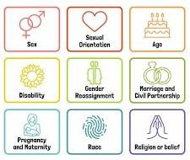
The protected characteristics are:
- Age (as an employer)
- Disability
- Gender reassignment
- Marriage and civil partnership
- Pregnancy and maternity
- Race
- Religion or belief
- Sex
- Sexual orientation
We actively promote equality and inclusion by embedding these principles into our curriculum, policies, and everyday interactions. In doing so, we celebrate diversity, challenge discrimination, and foster a culture of belonging where every pupil, member of staff, and family is valued as part of our school community.
Public Sector Equality Duty (PSED) - 2025

Equality Information and Objectives
Revised in conjunction with Equalities Policy and Statement)
Objectives 2025-29
Objectives |  | Planned Actions |  | Expected Impact /Review of Actions:
Foster Equality of opportunity for people with Protected Characteristics | Ensure the children of the school with all characteristics are represented in the curriculum through the projects, people and places studied and the resources used.  Ensure participation in enrichment opportunities is tracked and ensure all groups are attending.  Where groups are not attending, the reasons for this are explored and adaptations made to encourage and facilitate attendance. |  | Everyone at Ashbrook feels seen and like they belong.  Attendance at enrichment events is representative of all groups at Ashbrook
Eliminate Discrimination | Ensure any selection processes are aware of, and take account, of the school’s aims regarding equality and diversity- actions are taken to ensure all candidates are encouraged and supported to apply.  Ensure pupils are taught about discrimination through the curriculum and the collective worship programme.  Effectively challenge any hate incidents, investigating them fully and working with parents to educate when they do happen as well as following the behaviour policy when issuing consequences |  | The number Hate incidents reduce  Pupils can talk about discrimination and understand what it is.  Job adverts clearly state the school’s commitment to equity and diversity
Promote Equality  To ensure tolerance and respect towards individuals who identify with any of the protected characteristics (including neurodivergence) | Promote British Values regularly through the collective worship programme ensuring pupils understand what these mean.  Focus on the school’s values of respect and equity in collective worship and PHSE lessons, deepening pupils’ understanding of individual people’s need and the adaptations we may need to make to support them.  Engage in awareness raising and educational events/programmes about difference including neurodivergence awareness week and other relevant national and global awareness events |  | Pupils and the wider community have an increased awareness of the needs and strengths of different groups and show greater tolerance about the fact that different people require different adaptations and support.  Pupils demonstrate an understanding of the differing needs and experiences of different people at Ashbrook and the wider world.

Equality Information
This statement draws on monitoring and evaluation from the end of the 2024-2025 academic year and sets priorities for continued actions during 2025-26.
Equality information is updated annually to reflect the most recent data and the impact of actions taken.
December 2025



