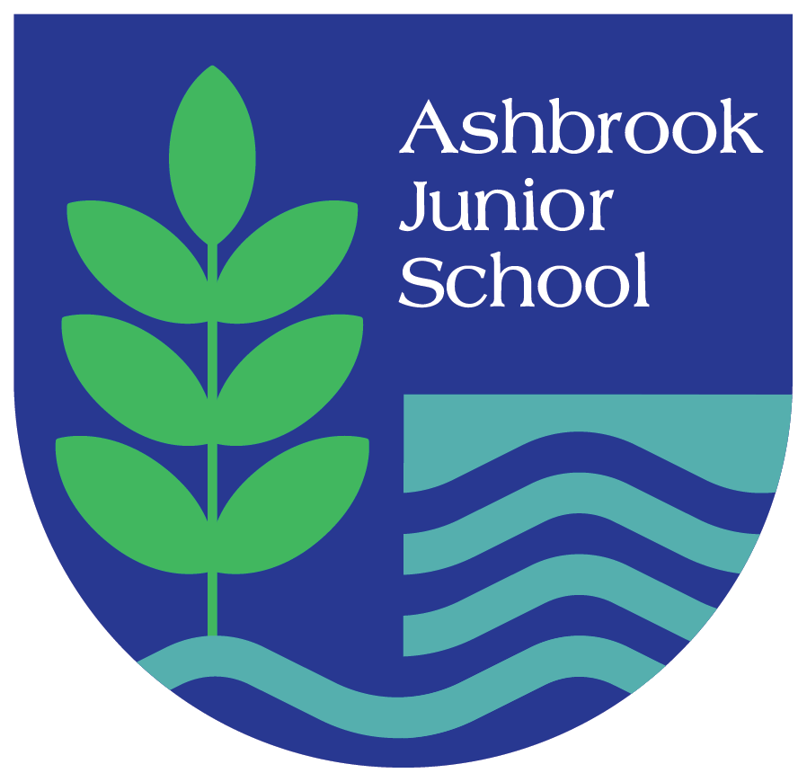

Ashbrook Junior School
EAL Policy
January 2026

Policy/Document Number | Author | Publication Date | Review Cycle
214 | Director of Inclusion | V1 January 2026 | Every 2 years

EAL Policy

At Ashbrook Junior School we are exceptionally proud of our pupils and value their abilities and achievements. We are confident that we provide a vibrant and stimulating learning environment that meets the needs of all our pupils. We want all our pupils to experience success in everything that they do, the school is fully committed to providing each pupil with the best possible learning environment for them to maximise their full potential.

THE EAL AIMS OF THE SCHOOL

- We consider a child’s home language to be a core element of their cultural identity.
- We aim to celebrate the range of languages spoken in the school and encourage continuing development in children’s home languages alongside their acquisition of the English language.
- We aim to support our bilingual and multilingual children to make rapid progress in their English language development through a focus on the teaching of core vocabulary in each subject, so that they can access learning in all areas of the curriculum.
- We are committed to ensuring that accurate assessment ensures that pupils are provided with learning tasks that meet both their cognitive and English language needs.
- We have an inclusive approach to learning and prioritise Quality First Teaching as the most effective way to enable EAL pupils to make the necessary progress required to diminish attainment differences with non-EAL pupils.
- Additional interventions will only be used in cases where it is determined that a child requires additional, not alternative, support to help them make the expected progress.

WHO IS THIS EAL POLICY FOR?

This policy should be referred to by all teaching, support and administrative staff who have contact with pupils and/or parents in the school. It informs strategic decision making by the senior leadership team, as well as day to day teaching and learning and interactions with parents and pupils of the school.
The aim of the policy is to ensure that bilingual and multilingual learners are provided with teaching and learning opportunities that enable them to make the best possible progress, within an accepting, inclusive and welcoming environment.

HOW IS EAL DEFINED?

Definition of English as an Additional Language taken from the Department for Education, 2019.

The term “EAL” is used to describe a diverse and heterogeneous group of learners who speak English as an Additional Language. In England, such learners are defined as those who have been ‘exposed to a language at home that is known or believed to be other than English’ (Department for Education, 2019).

Ashbrook Junior School’s definition of English as an Additional Language as those pupils where;

‘A first language, where it is other than English, is recorded where a child was exposed to the language during early development and continues to be exposed to this language in the home or in the community.’ (DfE School Census Guide 2016-2017, 2016 p.63)

Ashbrook Junior School’s definition of the different stages of English as an Additional Language;

- A: New to English (requiring considerable support to access curriculum content)
- B: Early Acquisition (still need a significant amount of support to access the curriculum)
- C: Developing Competence (need ongoing support to access the curriculum fully)
- D: Competent (occasional support to access more complex curriculum material and tasks)
- E: Fluent (very little or no support required to access curriculum content and should be working at, or very near, age related expectations)
Definitions of each band can be found in appendix 1.

ADMISSIONS

The admission arrangements for ALL pupils are in accordance with national legislation, including the Equality Act 2010.

INCLUSION

This policy builds on our school’s Inclusive ethos and approach, which recognises the entitlement of all pupils to a balanced, broadly based curriculum. Our EAL policy reinforces the need for teaching that is fully inclusive. The Governing Body will ensure that appropriate provision will be made for all pupils with EAL.

EAL CONTEXT AT ASHBROOK JUNIOR SCHOOL

Ashbrook Junior School is located in Borrowash, Derbyshire. We have a small number of pupils who speak English as an additional language (1.8%). This is lower than the national average of 23.4%. The main languages spoken at Ashbrook Junior School are English, Panjanbi, Ukrainian and French. Our pupils who are EAL are fluent in English. A small number of EAL pupils are also Pupil Premium (1%).

IDENTIFICATION

At Ashbrook Junior School we have adopted a whole-school approach to EAL policy and practice. All staff are committed to the principles and aims of this policy. Pupils identified as having EAL are, as far as it is practicable, fully integrated into mainstream classes. Every effort is made to ensure that they have full access to the National Curriculum and Early Years Foundation Stage Curriculum and are integrated into all aspects of the school. All teachers are responsible for identifying pupils with EAL and, in collaboration with the EAL Lead and EAL teacher, will ensure that those pupils requiring different or additional support are identified at an early stage. Assessment is the process by which pupils with EAL can be identified.

ADDITIONAL LANGUAGE ACQUISITION

We believe that the following should be in place to optimise the potential for second language acquisition for pupils with EAL:
- A welcoming and inclusive environment which celebrates ethnic and lingual diversity.
- Opportunities for pupils to explore ideas and new learning in their home language as well as in English.
- The continuing development of home language being seen as equally important as the development of English language skills.
- An inclusive curriculum, where EAL learners have access to high quality modelling of English language speaking by the adults around them.
- High expectations for all learners, regardless of their English language proficiency, where effective differentiation enables all pupils to access learning at a level appropriate for their cognitive and developmental needs.

GRADUATED RESPONSE AND EAL

The school adopts the levels of intervention as described in the SEND Code of Practice. The Code of Practice advocates a graduated response to meeting pupils’ needs. At Ashbrook Junior School, we have adopted a graduated response to meeting the needs of learners with EAL to ensure we are regularly reviewing the support in place for those acquiring English as an additional language.
The support provided consists of a four part process. See Appendix 2 for a breakdown of the graduated response to meeting the needs of our bilingual and multilingual learners

- Assess
- Plan
- Do
- Review
This is an on-going cycle to enable the provision to be refined and revised as the acquisition of the language progresses. This cycle enables identification of those interventions which are most effective in supporting the pupil to achieve good levels of progress and outcomes.

Staffing and Resources
The school currently has a small number of pupils with English as an Additional Language (EAL), all of whom demonstrate age-appropriate fluency in English. As such, the deployment of staff for EAL focuses on ongoing inclusion, monitoring, and ensuring access to the full curriculum rather than structured language interventions.
Class teachers have primary responsibility for meeting the needs of EAL learners within their classrooms. They ensure that teaching is differentiated where appropriate and that pupils have equal access to high-quality teaching and learning. The SENCo and Senior Leadership Team monitor pupil progress and advise staff if additional support becomes necessary.
At present, no dedicated EAL specialist staffing or targeted withdrawal provision is required. Should pupil needs change, the school will review staffing arrangements and implement appropriate strategies, interventions, or external support to ensure continued progress and inclusion.

Visual Support
Communication In Print is used to make visual resources which enable pupils with EAL to access the curriculum, as well as to navigate day to day school life.

All classes have a visual timetable, and language focus classes also use visuals to support classroom organisation.

Peer Support
Where possible, new pupils with EAL are buddied with another child who shares their home language.

Pupil Premium and EAL
A small percentage of the school’s pupil premium pupils are also EAL. Pupil Premium funding is deployed based on analysis of barriers to learning for disadvantaged learners and is not spent on a pupil by pupil basis.

Research has shown that the most effective way to raise attainment is through quality first teaching. A significant proportion of Pupil Premium Funding is therefore focused on staff CPD. It is our view that teaching strategies which support learners with EAL to access the curriculum in fact benefit all learners.

SPECIAL EDUCATIONAL NEEDS

At Ashbrook Junior School we are very clear that SEN and EAL are not the same. If a child with EAL is making slower than expected progress we first consider the following factors:
- Language proficiency
The child may be learning slowly due to limited experience in English. They may not have established sufficient proficiency in any language yet or, they may not be learning because their level of BICs has misled the teacher into setting tasks that are too abstract for the child’s language level.
- Environmental stress factors
These could be hindering learning both in and out of school. Examples are that the child may be experiencing racism either at home or at school or they may be stressed or traumatised. The family may be under a lot of stress, may have moved frequently or there may be conflicting demands in the home. It may be that the environment in the school is not inclusive and understanding.
- Access to the curriculum
There may be barriers created by the school that mean the child is not able to access the curriculum effectively. For example, the child may be discouraged from using his/her first language, there may be few visuals or gestures or the child may have been placed in an inappropriate set.

It is important to work through the list of possible hypotheses for the child’s perceived learning difficulties and to keep a thorough record, including recording where information is not known.

Once other reasons for slow progress have been investigated, further assessments are used to identify specific learning needs for pupils with EAL. These include: Dyslexia screening tools, reading fluency assessments, speech and language links, fine motor control handwriting assessment, physical literacy assessment, Maths assessments.

PARTNERSHIP WITH PARENTS

Ashbrook Junior School firmly believe in developing a strong partnership with parents and that this will enable children and young people with EAL to achieve their potential. The school recognises that parents have a unique overview of their child’s needs, and that this gives them a key role in the partnership.

The school aims to work in partnership with parents and carers. We do so by:

Parents are welcomed to the school during their child’s initial induction meeting. They have a tour of the school and are provided with key documents which explain the school’s expectations (for example, of attendance, uniform and behaviour) and daily school routines and organisation.

These documents are supported by visuals as we understand that many parents may speak little, or no English.

The school uses a variety of methods to maintain ongoing communication with parents including:
- The translation of letters home
- Text messaging
- Google Translate on the school’s website
- Parent coffee mornings with our Pastoral Team
- There are numerous opportunities each year for parents to become involved in the life of the school which include:
  - Workshops delivered by teachers to explain aspects of teaching (e.g. Reading Fluency and Reading at home Workshops)
  - Pupil performances
  - Curriculum open days
- Translating and Confidentiality
At Ashbrook Junior school we never use children or parents to support with the translation of any information that may be sensitive and/or confidential.

KEY RESPONSIBILITIES AND STAFF DEVELOPMENT

EAL Lead- Mrs Dell Head of School
The EAL Lead alongside other leaders in school are responsible for monitoring the progress and attainment of pupils with English as an additional language through; lesson visits, pupil and parent voice, book looks and analysis of assessment data.

They review and adapt the initial assessment and induction procedure to ensure it continues to meet the needs of pupils as well as providing the information needed by teachers to inform their planning.

The EAL Lead supports teaching staff by organising and/or delivering staff CPD in response to any issues arising from monitoring.

The EAL Lead attends EAL Network Meetings to ensure they remain informed about best practice in this area, and this information is disseminated to senior leaders and teaching staff as appropriate.

Teachers
Teachers are responsible for the attainment and progress of pupils with EAL in their class. They should raise any concerns over pupil progress with the SENDCo and EAL Lead.

Teachers are responsible for adapting the curriculum and providing resources to enable children with EAL to access learning.

EVALUATING THE SUCCESS OF OUR EAL POLICY

The EAL Governor will meet at least annually with the EAL Lead and the governor will report annually on the success of the policy against the specific objectives which are given under ‘The EAL Aims of the School’ at the beginning of this policy. The school adopts the Revise, Revisit, Refine and Refresh approach to ensure that the school is successfully meeting the needs of EAL pupils and parents, as well as suitable training and supporting staff.

COMPLAINTS PROCEDURE

Parents are encouraged to discuss any problems or concerns they may have with school. These should be raised initially with the pupil’s class teacher as most problems can be resolved in this way, but if this does not happen, parents may raise concerns with the EAL Lead and/or the Head teacher. If the issue cannot be resolved the parents may follow school’s Complaints Policy.

The EAL team at the school is:

Head of School: Mrs S Dell
EAL Lead: Mrs S Dell
Chair of Governors: Mr G Peel

Appendix 1
Proficiency in English Assessment

A: New to English
Pupils:
- Engage in highly scaffolded listening activities, learning basic classroom language
- and linking sounds to actions and meanings
- Show emerging competence in basic oral expression
- Demonstrate little or no knowledge of written English; taking first steps to engage
- with written and digital texts in English
- Demonstrate competence in managing basic, simple and isolated phrases
- Require considerable support to access curriculum content

B: Early Acquisition
Pupils:
- Show a developing autonomy in processing speech
- Show emerging competence in the ability to respond verbally in interactions with others
- Make sense of written text at word and phrase/sentence level, using visual information to help decipher meaning
- Demonstrate competence in producing simple sentences and paragraphs on familiar topics conforming to taught expectations
- Still need a significant amount of support to access the curriculum
During the New to English and Early Acquisition stages, the focus for teaching and support should be on effective communication and ‘meaning making’. At these stages fluency and building confidence is more important than accuracy.

C: Developing Competence
Pupils in the English education system who are Developing Competence, have typically been learning English for between two and five years.
At this stage learners would typically be confident in communicating in English and would be starting to develop more control of functional language. Their spoken English, however, may not be particularly accurate, with surface errors sometimes continuing for a number of years.

Pupils:
- Show developing independence in the use of basic listening skills needed to engage with learning
- Demonstrate emerging competence in spontaneous expression and communication
- Draw on growing knowledge of vocabulary and grammar to engage with curriculum and related texts and tasks
- Demonstrate competence in describing and narrating personal experiences with greater accuracy and beginning to experiment with more sophisticated writing in a variety of genres in different curriculum contexts
- Need ongoing support to access the curriculum fully

At this stage, the focus for teaching and support should be about increasing range and accuracy of language use. EAL learners who are Developing Competence need to be encouraged to notice key features of English and self-correct.

D: Competent
Pupils:
- Apply listening skills over an increasing range of contexts and functions
- Demonstrate competence in producing more varied and complex speech in a wider range of contexts
- Engage with curriculum related reading activities independently and productively in different subject areas
- Demonstrate competence in controlling the content and structure of writing with greater accuracy and with a fuller range of vocabulary and grammar
- Need occasional support to access more complex curriculum material and tasks

E: Fluent
Pupils:
- Demonstrate confidence in writing accurately and independently in a variety of genres
- Engage with curriculum-related reading activities independently and productively in different subject areas
- Show competence in fluent, creative use of spoken English
- Show an ability to understand and respond to spoken communication in classroom and school contexts with little or no hindrance
- Need very little or no support required to access curriculum content and should be working at, or very near, age related expectations

At the Competent and Fluent stages, the focus for teaching and support should be about promoting more sophisticated uses of language, exploring how to control of genre and register, and varying style and format to adapt to different requirements and contexts.

These assessments are saved on INSIGHT and help to support leadership decision making, for example the allocation of resources and deployment of support staff.

Appendix 2
Graduated Response

ASSESS

Initial Assessment
New arrivals to the school who have English as an additional language (EAL) are assessed in the following areas, after a settling in period of a maximum of 4 weeks, at the school:
- Phonics awareness (English)
- Reading fluency assessments

Proficiency in English Assessment
Teachers assess the Proficiency in English (PiE) of EAL pupils in their class three times per year; at the end of the Autumn 1, Spring 1 and the start of Summer 2 (to aid transition) terms. This assessment is completed using the Flash Academy Assessment tool which is supported by the Bell Foundation EAL Assessment descriptors and establishes a child’s proficiency levels. See Appendix 1 for an outline of the Proficiency levels.

Statutory Assessments
The school carries out the following statutory assessments:
- Year 4: Multiplication Check
- Year 6: SATS in Reading, Writing, Maths and Grammar, Punctuation and Spelling

In some cases, it is not appropriate for a child who is very new to English to sit statutory tests, as they do not have enough English language to access the test. Teachers will make the decision on whether to disapply a child with EAL from statutory assessments based on their judgement of whether it is suitable for their needs.

The school follows statutory testing guidance and provides approved support to help pupils with EAL to access tests including, where guidance allows, the provision of translators and/or readers e.g. in maths assessments, additional time (for pupils with low writing or reading speed) and scribes.

Internal Assessments

The school carries out termly assessments in Reading, Writing and Maths (see Assessment Policy for further information). If a pupil with EAL is unable to access the tests provided, teachers instead provide a teacher assessment level. This is supported by their knowledge of the pupils’ performance in class.

PLAN AND DO

Across school, classes are taught based on year group classes and we currently have 1-2 classes in every year group.

We use the Monster phonics programmes for our delivery of phonics intervention. Groupings, are fluid enabling pupils to move groups where necessary in order to best meet their developing needs.

Within year groups, the focus is on language immersion and strong modelling of spoken English skills by adults. Teaching and Learning staff use a variety of strategies to support EAL learners to access the curriculum. These include:
- The use of visuals and opportunities for oral rehearsal to support understanding and language development (e.g. Communication in Print)
- Focus on the explicit teaching of vocabulary
- Effective feedback, including recasting/remodelling of spoken English.
- Pre and post teaching of key skills and vocabulary for pupils that require additional support.
- The use of specific language intervention for pupils with EAL that are not making the expected progress in English language development and have been assessed as requiring additional support (e.g. identified SEND including speech and language difficulties).

Teachers have high expectations of all pupils, and plan work in order to meet the cognitive and language needs of each child. The focus is on enabling EAL pupils to make the progress necessary in order to help them close any attainment gap they may have in comparison to non-EAL peers.

Classroom organisation supports independent learning by ensuring resources are easily accessible for all pupils. All classes should ensure that resources are clearly labelled, and labels should include images of resources to reinforce this language development.

Higher achieving EAL pupils should be supported in their learning by effective adaptations which matches learning to pupils’ cognitive needs.

The teaching of vocabulary underpins learning in all areas of the curriculum and school life. Teaching and Learning staff should maximise every opportunity for language learning, in both planned and incidental interactions with pupils i.e. whether within lessons or in the dinner hall.

Progression and guidance documents for each subject, outline the tier one, tier two and tier three vocabulary to be taught each half term. This ensures that pupils with EAL are able to build on their cognitive academic language proficiency, with the aim of supporting EAL pupils to become fluent English speakers who can access the curriculum at an age appropriate level with no additional support.

REVIEW

In addition to the standard assessments used within school (please refer to the Assessment Policy), pupils with EAL are also assessed in line with the DfE Proficiency in English codes three times a year (Autumn, Spring and Summer assessment points). These assessments are supported by the Bell Foundation Assessment and Flash Academy Assessment.

Proficiency in English levels are compared to a child’s length of time in English schooling, and targets are set based on the aim of supporting children with EAL to develop Cognitive Academic Language Proficiency (CALP) within five years. Research suggests that “It takes learners at least five years to develop CALP. Research from Collier and Thomas (1995) has shown that it may take children with no prior instruction or no support in native language development at least seven years to develop CALP.”

We also aim to ensure that pupils with EAL are able to develop their Basic Interpersonal Communication Skills (BICS) in English in between six months to two years. “Basic Interpersonal Communication Skills (BICS) refer to linguistic skills needed in everyday, social face-to-face interactions. For instance, the language used in the playground, on the phone, or to interact socially with other people is part of BICS. The language used in these social interactions is context embedded. That is, it is meaningful, cognitively undemanding, and non-specialised. It takes the learner from six months to two years to develop BICS.”

The curriculum is adapted where necessary to ensure that pupils with EAL access learning at a level appropriate to their language and cognitive needs.

