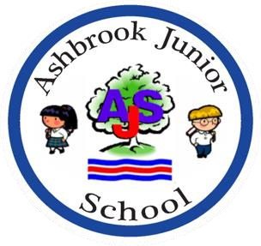

Ashbrook Junior School
RHE Policy 2025-26

Author | Publication Date | Review Cycle
Heather Tarrant Executive Headteacher | November 2025 | Annually

Ashbrook JuniorSchool
Relationships and Health Education Policy 2025-26
Introduction
This policy has been written in accordance with the statutory guidance from the Department for Education issued under Section 80A of the Education Act 2002 and section 403 of the Education Act 1996. This policy contains information on how our school will meet its legal duties, with which schools must comply, when teaching Relationships Education and Health Education.
The Relationships Education and Health Education (England) Regulations 2019, make Relationships Education compulsory for all pupils receiving primary education. They also make Health Education compulsory in all schools except independent schools. Personal, Social, Health and Economic Education (PSHE) continues to be compulsory in independent schools.
For the purpose of this policy, “relationships and sex education” is defined as teaching pupils about healthy, respectful relationships, focussing on family and friendships, in all contexts, including online.
For the purpose of this policy, “health education” is defined as teaching pupils about physical health and mental wellbeing, focussing on recognising the link between the two and being able to make healthy lifestyle choices.
Development of the Policy
This policy has been developed by working in Partnership with schools in Derby City. A core focus of this partnership was seeking and gaining the views of local religious and community groups, ensuring representation of the protected characteristics of the Equality Act 2010.
Consultation with parents
The school understands the important role parents play in enhancing their children’s understanding of relationships and health. Similarly, we also understand how important parents’ views are in shaping the curriculum.
The school works closely with parents by establishing open communication. Parents are provided with the following information:
- The content of the relationships and health curriculum
- The delivery of the relationships and health curriculum, including what is taught in each year group
- The legalities surrounding withdrawing their child from the subjects
- The resources that will be used to support the curriculum

The school aims to build positive relationships with parents by inviting them into school to discuss what will be taught, address any concerns and help parents in managing conversations with their children on the issues covered by the curriculum.
Parents will be informed annually at parents meetings, through the school website and through termly year group letters about the content of the Relationships and Heath Education taught in each year group. Parents will be invited to discuss the content with the class teacher. In addition, parents will be consulted in the review of the curriculum and this policy, and are encouraged to provide their views at any time.
Curriculum Content
Relationships and health education focusses on giving pupils the knowledge they need to make informed decisions about their wellbeing, health and relationships, and to build their self-efficacy. Health education focusses on equipping pupils with the knowledge they need to make good decisions about their own health and wellbeing.
We understand our responsibility to deliver a high-quality, age-appropriate relationship and health curriculum for all our pupils. This policy sets out the framework for our relationships and health curriculum, providing clarity on how it is informed, organised and delivered.

Relationships Education
The focus in primary school should be on teaching the fundamental building blocks and characteristics of positive relationships, with particular reference to
- Families and people who care about me
- Caring friendships
- Respectful relationships
- Online relationships
- Being safe

See table below for the content laid out in the DfE Guidance:
Families | - That families are important for children growing up because they can give love, security and stability  - The characteristics of healthy family life, commitment to each other, including in times of difficulty, protection and care for children and other family members, the importance of spending time together and sharing each other’s lives  - That others’ families, either in school or in the wider world, sometimes look different from their family, but that they should respect those differences and know that other children’s families are also characterised by love and care  - That stable, caring relationships, which may be of different types, are at the heart of happy families, and are important for children’s security as they grow up  - That marriage represents a formal and legally recognised commitment of two people to each other which is intended to be lifelong  - How to recognise if family relationships are making them feel unhappy or unsafe, and how to seek help or advice from others if needed

Caring Relationships |  | - How important friendships are in making us feel happy and secure, and how people choose and make friends  - The characteristics of friendships, including mutual respect, truthfulness, trustworthiness, loyalty, kindness, generosity, trust, sharing interests and experiences and support with problems and difficulties  - That healthy friendships are positive and welcoming towards others, and do not make others feel lonely or excluded  - That most friendships have ups and downs, and that these can often be worked through so that the friendship is repaired or even strengthened, and that resorting to violence is never right  - How to recognise who to trust and who not to trust, how to judge when a friendship is making them feel unhappy or uncomfortable, managing conflict, how to manage these situations and how to seek help or advice from others, if needed
Respectful Relationships | - The importance of respecting others, even when they are very different from them (for example, physically, in character, personality or backgrounds), or make different choices or have different preferences or beliefs  - Practical steps they can take in a range of different contexts to improve or support respectful relationships  - The conventions of courtesy and manners  - The importance of self-respect and how this links to their own happiness  - That in school and in wider society they can expect to be treated with respect by others, and that in turn they should show due respect to others, including those in positions of authority  - About different types of bullying (including cyberbullying), the impact of bullying, responsibilities of bystanders (primarily reporting bullying to an adult) and how to get help  - What a stereotype is, and how stereotypes can be unfair, negative or destructive  - The importance of permission-seeking and giving in relationships with friends, peers and adults
- That people sometimes behave differently online, including by pretending to be someone they are not
- That the same principles apply to online relationships as to face-to face relationships, including the importance of respect for others online including when we are anonymous
- The rules and principles for keeping safe online, how to recognise risks, harmful content and contact, and how to report them
- How to critically consider their online friendships and sources of information including awareness of the risks associated with people they have never met
- How information and data is shared and used online
Being safe | - What sorts of boundaries are appropriate in friendships with peers and others (including in a digital context)  - About the concept of privacy and the implications of it for both children and adults; including that it is not always right to keep secrets if they relate to being safe  - That each person’s body belongs to them, and the differences between appropriate and inappropriate or unsafe physical, and other, contact  - How to respond safely and appropriately to adults they may encounter (in all contexts, including online) whom they do not know  - How to recognise and report feelings of being unsafe or feeling bad about any adult  - How to ask for advice or help for themselves or others, and to keep trying until they are heard  - How to report concerns or abuse, and the vocabulary and confidence needed to do so  - Where to get advice e.g. family, school and/or other sources

Health Education
The aim of teaching pupils about physical health and mental wellbeing is to give them the information that they need to make good decisions about their own health and wellbeing. It should enable them to recognise what is normal and what is an issue in themselves and others and, when issues arise, know how to seek support as early as possible from appropriate sources.
- Mental well -being
- Internet safety and harms
- Physical health and fitness
- Healthy eating
- Drugs, alcohol and tobacco
- Health and prevention
- Basic first aid
- Changing adolescent body

See table below for the content laid out in the DfE Guidance:
Mental wellbeing | - Mental wellbeing is a normal part of daily life, in the same way as physical health.  - There is a normal range of emotions (e.g. happiness, sadness, anger, fear, surprise, nervousness) and scale of emotions that all humans experience in relation to different experiences and situations.  - How to recognise and talk about their emotions, including having a varied vocabulary of words to use when talking about their own and others’ feelings.  - How to judge whether what they are feeling and how they are behaving is appropriate and proportionate.  - The benefits of physical exercise, time outdoors, community participation, voluntary and service-based activity on mental wellbeing and happiness.  - Simple self-care techniques, including the importance of rest, time spent with friends and family and the benefits of hobbies and interests.  - Isolation and loneliness can affect children and that it is very important for children to discuss their feelings with an adult and seek support.  - Bullying (including cyberbullying) has a negative and often lasting impact on mental wellbeing.  - Where and how to seek support (including recognising the triggers for seeking support), including whom in school they should speak to if they are worried about their own or someone else’s mental wellbeing or ability to control their emotions (including issues arising online).  - It is common for people to experience mental ill health. For many people who do, the problems can be resolved if the right support is made available, especially if accessed early enough.
Internet safety and harms | - For most people the internet is an integral part of life and has many benefits.  - About the benefits of rationing time spent online, the risks of excessive time spent on electronic devices and the impact of positive and negative content online on their own and others’ mental and physical wellbeing.  - How to consider the effect of their online actions on others and know how to recognise and display respectful behaviour online and the importance of keeping personal information private.  - why social media, some computer games and online gaming, for example, are age restricted.  - the internet can also be a negative place where online abuse, trolling, bullying and harassment can take place, which can have a negative impact on mental health.  - How to be a discerning consumer of information online including understanding that information, including that from search engines, is ranked, selected and targeted.  - Where and how to report concerns and get support with issues online
Physical Health and Fitness | - The characteristics and mental and physical benefits of an active lifestyle.  - The importance of building regular exercise into daily and weekly routines and how to achieve this; for example walking or cycling to school, a daily active mile or other forms of regular, vigorous exercise.  - The risks associated with an inactive lifestyle (including obesity).  - How and when to seek support including which adults to speak to in school if they are worried about their health.
Health Eating | - What constitutes a healthy diet (including understanding calories and other nutritional content).  - The principles of planning and preparing a range of healthy meals.  - The characteristics of a poor diet and risks associated with unhealthy eating (including, for example, obesity and tooth decay) and other behaviours (e.g. the impact of alcohol on diet or health).
Drugs alcohol and tobacco | - The facts about legal and illegal harmful substances and associated risks, including smoking, alcohol use and drug-taking.
Health and Prevention | - How to recognise early signs of physical illness, such as weight loss, or unexplained changes to the body.  - About safe and unsafe exposure to the sun, and how to reduce the risk of sun damage, including skin cancer.  - The importance of sufficient good quality sleep for good health and that a lack of sleep can affect weight, mood and ability to learn.  - About dental health and the benefits of good oral hygiene and dental flossing, including regular check-ups at the dentist.  - About personal hygiene and germs including bacteria, viruses, how they are spread and treated, and the importance of handwashing.  - The facts and science relating to allergies, immunisation and vaccination.
Basic First Aid | - How to make a clear and efficient call to emergency services if necessary.  - Concepts of basic first-aid, for example dealing with common injuries, including head injuries.
Changing adolescent body | - Key facts about puberty and the changing adolescent body, particularly from age 9 through to age 11 including physical and emotional changes.  - About menstrual wellbeing including the key facts about the menstrual cycle.

Delivery
Relationships and Health Education is taught throughout the whole school curriculum. This includes within the Personal, Social, Health Education (PSHE) curriculum, science curriculum, Physical Education (PE), computing and some aspects are included in religious education (RE). (Please see appendix 3 for coverage of the statutory content across the school’s curriculum.)
Pupils will mainly be taught in their class groups. Single gender lessons will be used as deemed appropriate by the school eg about the changing body. It is important to note that although separated groups may have different activities, the messages and information they receive will be consistent. It is important that children learn about all changes not just their own.
Through effective organisation and delivery of the subject, we will ensure that:
- Core knowledge is sectioned into units of manageable size.
- The required content is communicated to pupils clearly, in a carefully sequenced way, within a planned scheme of work.
- Teaching includes sufficient and well-chosen opportunities and contexts for pupils to embed new knowledge so that it can be used confidently in real-life situations.

In addition, teachers will:
- Deliver a high-quality and age-appropriate relationships and health curriculum in line with school and statutory requirements.
- Use a variety of teaching methods and resources to provide an engaging curriculum that meets the needs of all pupils.
- Ensure they do not express personal views or beliefs when delivering the programme.
- Model positive attitudes to relationships and health education.
- Respond to any safeguarding concerns in line with the Child Protection and Safeguarding Policy.

Questions
Teachers will attempt to answer pupils’ questions and concerns in a sensitive, age and development appropriate manner. Individual teachers will use skill and discretion in these situations and refer to Relationships and Health Education Lead.

Teachers will apply the following principles:

- Clear ground rules will be established and set out for each session
- Pupil questions will be encouraged and opportunities to ask questions openly and in private eg. post it notes/question boxs will be provided
- Clarity about the topics being taught will be shared with pupils
- If a child’s question is not appropriate to answer in front of the class, the teacher will explain calmly that this is not part of today’s discussion and will discuss later.
- Individual questions may be answered by the teacher at the end of the session.
- Some questions may be referred to the child’s parents to provide an answer; in these circumstances the class teacher will make contact.

All staff members at the school will undergo training on a yearly basis to ensure they are up-to-date with the relationship and health education programme and associated issues.
Members of staff responsible for teaching the subjects will undergo further training led by the relationships, sex and health education subject leader, to ensure they are fully equipped to teach the subjects effectively.
Training of staff will also be scheduled around any updated guidance on the programme and any new developments, which may need to be addressed in relation to the programme.

Equality and accessibility
The school creates a safe environment where all staff and children are respected and free to express their beliefs and opinions without fear of discrimination. The school understands its responsibilities in relation to the Equality Act 2010, specifically that it must not unlawfully discriminate against:
  - Women/girls and men/boys
  - People of different races
  - Disabled people
  - People with different religions or beliefs or with no religion or belief
  - People of different ages
  - Lesbian, gay and bisexual and straight people
  - People who have changed their sex

The school is committed to making reasonable adjustments wherever possible to promote accessibility and inclusivity of the curriculum. The school understands that pupils with SEND or other needs (such as those with social, emotional or mental health needs) are entitled to learn about relationships and health education, and the programme will be designed to be inclusive of all pupils.
Teachers will understand that they may need to be more explicit and adapt their planning of work and teaching methods in order to appropriately deliver the programme to pupils with SEND or other needs.
The curriculum will be taught within the context of family life, taking care to ensure that there is no stigmatisation of children based on their home circumstances (families can include a mum and a dad, blended families (step/half siblings) single parent families, LGBT parents, families headed by grandparents, adoptive parents, foster parents/carers amongst other structures) along with reflecting sensitively that some children may have a different structure of support around them (for example: looked after children or young carers).
Provisions under the Equality Act 2010 allow our school to take positive action, where it can be evidenced to be proportionate, to respond to particular disadvantages affecting a group because of a protected characteristic. When deciding whether support is necessary to support pupils with a particular protected characteristic, we will consider our pupils’ needs, including the gender and age range of our pupils.
We will encourage children to be respectful of the differences between boys and girls, but we will also be careful of assuming that boys and girls have distinct characteristics which can lead to negative stereotyping. For example, we will discourage negative characterisation of gender such as “boys don’t cry”, or “girls shouldn’t play football” and dispel any manifestations of discrimination from an early age. In order to foster healthy and respectful peer-to-peer communication and behaviour between boys and girls, the school implements a robust Behaviour Policy, which set out expectations of pupils.
Sex education
All pupils must be taught the aspects of sex education outlined in the primary science curriculum – which includes teaching about the main external parts of the human body, how the human body changes as it grows from birth to old age, including puberty, and the reproductive process in some plants and animals.
The school is free to determine whether pupils should be taught sex education beyond what is required of the national curriculum. At our school, we do not teach pupils sex education beyond what is required of the science curriculum.
In line with our school’s safeguarding policy, if a child is at risk of sexual harm, additional actions will be taken to ensure children have the knowledge and skills to keep themselves and others safe.
Parents’ right to withdraw
Parents do not have the right to withdraw their children from relationships education or the programme of study as part of the requirements of the science curriculum. The school will continue to teach the science curriculum as set out in the National Curriculum (see appendix 4 for objectives taught and terminology used). The changing of the adolescent body topics will be taught in single sex groups and, where possible, by a member of staff of the same gender.
Monitoring and review
This policy will be reviewed on an annual basis by the relationships health education subject lead, Headteacher and governors. The next scheduled review date for this policy is September 2026.
This policy will also be reviewed in light of any changes to statutory guidance, feedback from parents, staff or pupils, and issues in the school or local area that may need addressing.
The governing board is responsible for approving this policy.
Any changes made to this policy will be communicated to all staff, parents and, where necessary, pupils by a parents’ meeting, the newsletter and the website.

Date policy approved: Decmeber 2025
Date of next review:September 2026

Appendix 1
Vocabulary to be taught: (Liaison with the Infant School to ensure coverage at Key Stage 1)
Y1 :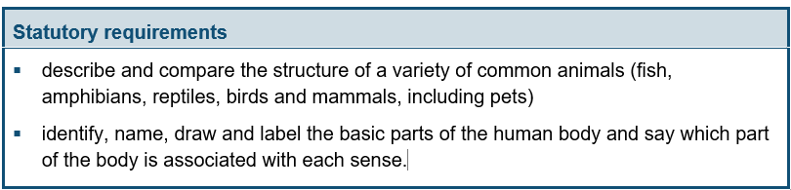

Notes and guidance (non-statutory)
Pupils should use the local environment throughout the year to explore and answer questions about animals in their habitat. They should understand how to take care of animals taken from their local environment and the need to return them safely after study. Pupils should become familiar with the common names of some fish, amphibians, reptiles, birds and mammals, including those that are kept as pets.
Pupils should have plenty of opportunities to learn the names of the main body parts (including head, neck, arms, elbows, legs, knees, face, ears, eyes, hair, mouth, teeth) through games, actions, songs and rhymes.
Pupils might work scientifically by: using their observations to compare and contrast animals at first hand or through videos and photographs, describing how they identify and group them; grouping animals according to what they eat; and using their senses to compare different textures, sounds and smells.
Y2:
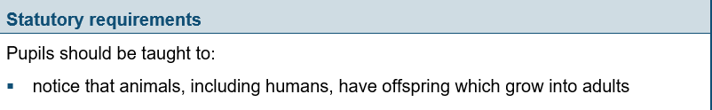
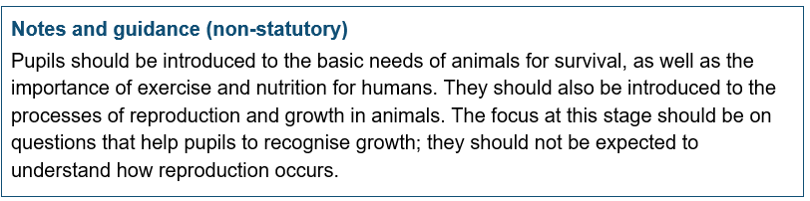
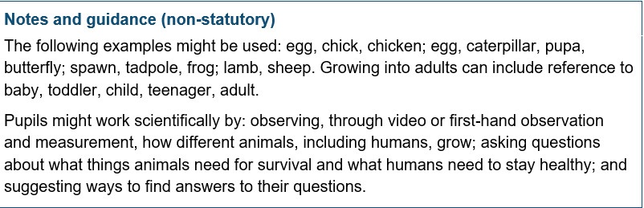
Y3,4 – nothing linked
Y5:
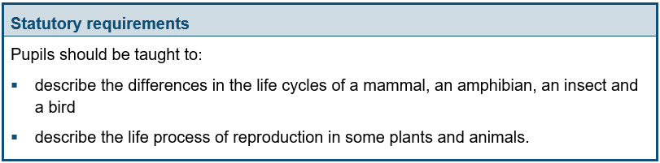
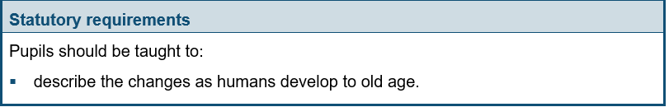
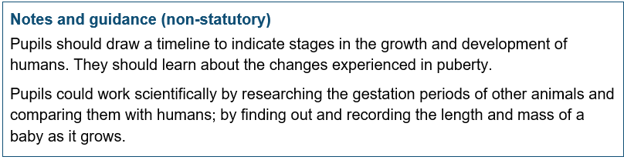
Y6:
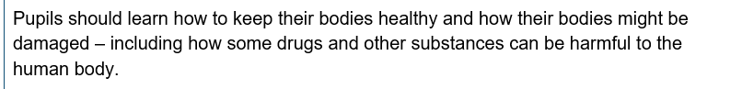

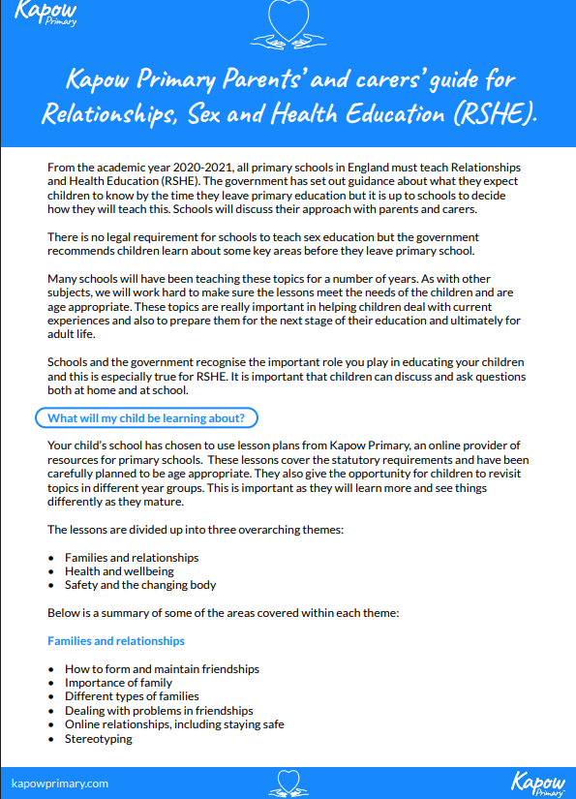

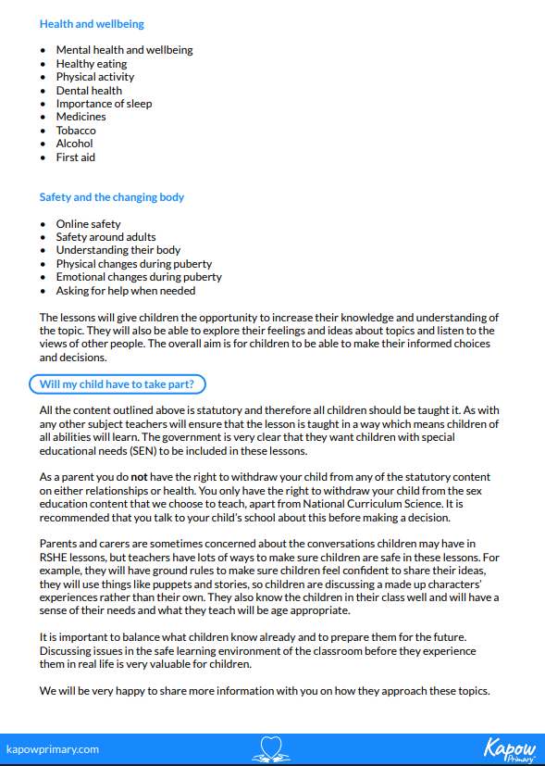

Appendix 4: Objectives taught and terminology used in the science curriculum as set out in the National Curriculum

