

Transform Trust
Assessment

Policy Number | Author | Publication Date | Review Cycle
006 | Associate Headteacher for Assessment | V6 September 2026 | Annually

Contents
- Aims
- Legislation and guidance
- Principles of assessment
- Assessment approaches
- Collecting and using data
- Reporting to parents
- Inclusion
- Training
- Roles and responsibilities
- Monitoring
- Links with other policies
- Aims
This policy aims to:
- Provide clear guidelines on our approach to formative and summative assessment
- Establish a consistent and coherent approach to recording summative assessment outcomes and reporting to parents
- Clearly set out how and when assessment practice will be monitored and evaluated

- Legislation and guidance

Since the removal of National Curriculum levels in 2014, schools have been free to develop their own approaches to assessment.
This policy refers to the recommendations in the Final Report of the Commission on Assessment without Levels.
It also refers to statutory reporting requirements set out in the Education (Pupil Information) (England) Regulations 2005: schedule 1.
This policy complies with our funding agreement and articles of association.

- Principles of assessment

Assessment is an integral part of teaching and learning. It is the process through which pupils’ attainment and progress are recognised and is used to raise outcomes for all pupils from their individual starting points.

The key purposes of assessment are:

- Curriculum - to enable the identification of pupils’ progress and needs, to evaluate the effectiveness of teaching in enabling learning and motivating pupils.
- Communication - to provide appropriate information for a range of audiences: pupils, parents and carers, teachers, governors other educational institutions, agencies and employers.
- Accountability - to enable teachers to show how they are fulfilling their aims and meeting school requirements.

Assessment for learning and assessment of learning are different but compatible and complementary. The principle aim of assessment should be to inform teaching and learning and not focus purely on purposes related to accountability.

Assessment, recording and reporting should:
- offer all pupils an opportunity to be involved in showing what they know, understand, can do and what they need to develop;
- support the setting of projections that are based on the highest expectations;
- recognise that the National Curriculum does not encompass all learning. That there is the wider curriculum which includes pupils’ personal, social and emotional development;
- provide effective feedback for pupils and adults;
- involve different professionals and other agencies as appropriate, recognising the contribution all make to the process;
- be rigorous and consistent.
- follow the principles for data management, as set out in ‘Making Data Work’, a report of the Teacher Workload Advisory Group (2018)

- Assessment approaches
At Transform Trust, we see assessment as an integral part of teaching and learning, and it is inextricably linked to our schools’ curriculums.

4.1 In-school formative assessment

Effective in-school formative assessment enables:
- Teachers to identify how pupils are performing on a continuing basis and to use this information to provide appropriate support or extension, evaluate teaching and plan future lessons
- Pupils to measure their knowledge and understanding against learning objectives, and identify areas in which they need to improve
- Parents to gain a broad picture of where their child’s strengths and weaknesses lie, and what they need to do to improve

Assessment is embedded in the teaching and learning process – see individual school’s teaching and learning policies.
4.2 In-school termly assessment
Assessments are carried out each term for pupils in reading, writing and maths drawing on this evidence:
- Teacher assessment of writing alongside moderation in-school and across the Trust using the Trust writing standards
- End of term tests of maths and reading using the Smartgrade Assessment Series (SAS) assessments (Y1-5)
- Y6 reading and maths is assessed using KS2 SATs papers from previous years (order identified in Transform’s Assessment Timetable)
- Nursery children are assessed against the 7 areas of the EYFS curriculum and Trust typicality documents
- Reception children are assessed against the 17 Early Learning Goals using Development Matters
- Y1 children are assessed against their school’s phonics scheme and judged as to whether they are on track to pass the Phonics Screening Check
All children are also assessed using the Leuven Scale for Wellbeing and Involvement – see Appendix 2 for Transform adapted Leuven Scales for all year groups.
Children who have English as an Additional Language (EAL) are assessed using the Bell Foundation English proficiency framework. This five-band framework assesses: speaking, listening, reading and writing.
Effective in-school termly assessment enables:
- School leaders to monitor the performance of pupil cohorts, identify where interventions may be required, and work with teachers to ensure pupils are supported to achieve sufficient progress and attainment
- Teachers to evaluate learning at the end of a unit or period and the impact of their own teaching
- Pupils to understand how well they have learned and understood a topic or course of work taught over a period of time. It should be used to provide feedback on how they can improve
At Transform Trust, we believe that these termly assessments are formative assessments. Outcomes from these assessments should be analysed and lead to a change in teaching.
4.3 Nationally standardised summative assessment
Nationally standardised summative assessment enables:
- School leaders to monitor the performance of pupil cohorts, identify where interventions may be required, and work with teachers to ensure pupils are supported to achieve sufficient progress and attainment
- Teachers to understand national expectations and assess their own performance in the broader national context
- Pupils and parents to understand how pupils are performing in comparison to pupils nationally

Nationally standardised summative assessments include:
- Early Years Foundation Stage (EYFS) baseline
- Phonics Screening Check in year 1
- Multiplication Times Tables Check in year 4
- National Curriculum tests and teacher assessments at the end of Key Stage 2 (year 6)

4.4 Assessment of Science and Foundation Subjects
Schools must assess Science and Foundation Subjects. It is recommended that schools use the Transform Trust principles for the assessment of Science and Foundation Subjects. The recording of these assessments is a school-level decision. As with all other assessments, the analysis of the data produced should inform the next steps of teaching.

- Collecting and using data

  - School level
Data will be collected by schools at regular intervals across the school year. Schools are encouraged to use the Question Level Analysis on Smartgrade to identify gaps leading to changes in teaching. Teachers are expected to use their data to prepare for pupil progress meetings with school leaders in which individual children are discussed. School leaders will use the data to prepare for termly progress meetings with the Trust Partnership Director.
5.2 Trust level
Data will be used at Trust level to identify Trust priorities for school support and for professional development. Smartgrade will be used by Trust Maths and English leaders to identify areas for development across the whole Trust and in individual schools. Data will be used by Trustees to develop a whole Trust understanding of attainment.

- Reporting to parents
Schools are expected to report on assessment information for parents across the school year at parents’ evenings and in end of year reports.

- Inclusion
The principles of this assessment policy apply to all pupils, including those with special educational needs or disabilities.
The Trust Access Arrangements Protocol sets out how we expect them to be used to support children to access the termly assessments (see Appendix 1).
Assessment will be used diagnostically to contribute to the early and accurate identification of pupils’ special educational needs and any requirements for support and intervention.
We will use meaningful ways of measuring all aspects of progress, including communication, social skills, physical development, resilience and independence. We will have the same high expectations of all pupils. However, this should account for the amount of effort the pupil puts in as well as the outcomes achieved.
For pupils working below the national expected level of attainment, our assessment arrangements will consider progress relative to pupil starting points and take this into account alongside the nature of pupils’ learning difficulties.

- Training
All staff have access to training videos provided by the Trust Assessment Leader. These show how to use the online platforms: Insight and Smartgrade.

School assessment leaders are invited to view recordings of Assessment Briefings and receive termly Assessment Newsletters. These both set out expectations as well as up-to-date information about assessment.

Regular opportunities for moderation between partnerships of schools are organised by the Transform central team: EYFS Associate Headteacher, Writing Leader and Assessment Leader.

- Roles and responsibilities

9.1 Transform Assessment Lead
The Trust Assessment Lead is responsible for:
- Producing an up-to-date yearly assessment timetable
- Running training for all staff
- Producing data packs for use by the Transform Central team following each assessment point
- Writing and reviewing the Trust assessment policy
- Liaising with Insight and Smartgrade – communicating changes when needed
- Producing data packs at the end of each year for the CEO and Trustees

  - Governors
Governors are responsible for:
- Being familiar with statutory assessment systems as well as how the school’s own system of non- statutory assessment captures the attainment and progress of all pupils
- Holding school leaders to account for improving pupil and staff performance by rigorously analysing assessment data

  - Headteacher(s)
The Headteacher is responsible for:
- Ensuring that the policy is adhered to
- Monitoring standards in core and foundation subjects
- Analysing pupil progress and attainment, including individual pupils and specific groups
- Prioritising key actions to address underachievement
- Reporting to governors on all key aspects of pupil progress and attainment, including current standards and trends over previous years
- Identify a named Assessment Leader for their school

  - Teachers
Teachers are responsible for following the assessment procedures outlined in this policy, identifying any underachievement and actioning any interventions required.

Glossary of Key Terms
Term | Description
Assessment | The process of testing understanding and progress in learning.
Attainment | A measure of what a pupil knows at a specific point in their learning.  This measure can be reported as a numerical score (e.g. 75%) or as a descriptor (e.g. EXS).
Expected Standard (EXS) | An attainment measure that indicates that a child or group have demonstrated understanding of the curriculum objectives for their year group and, as such, are working at an age-related expectation.
Floor Standard | The floor standard is the minimum standard for pupil attainment and progress that the government expects schools to meet.
Good Level of Development (GLD) | An attainment measure that indicates that at the end of the Early Years Foundation Stage a child has achieved the expected level in the early learning goals in:  - the prime areas of learning (personal, social and emotional development; physical development; and communication and language)  - and, in specific areas of mathematics and literacy.  The GLD measure indicates readiness for Year 1.
Greater Depth standard (GDS) | An attainment measure that indicates that a child or group can demonstrate that they can apply knowledge of the curriculum to work successfully and independently with more complex or non-standard tasks, including reasoning and making links and connections between different areas of learning.
Prediction | The attainment measure that a child or group are expected to achieve in the future based on consideration of their historical and current attainment measures.
Progress | A measure that indicates if a child is on track to achieve their projected attainment target.
Projection | The attainment measure that children are expected to get using what we know about their performance to date e.g.  - at the end of KS1 based on their end of EYFS attainment  - at the end of KS2 based on their end of KS1 attainment.
Raw Attainment Score | The actual number of marks a pupil scores in an assessment (e.g. 60 out of 110)
Scaled Attainment Score | A scaled attainment score (used in SATS) is different to a standardised score.  A scaled attainment score is a raw score that is converted to a specific scale that has been set up to ensure that a certain percentage of children who write the test always meet a certain criteria. For example, in SATS a score 100 or more is set as the threshold for having achieved the ‘expected standard’, and every year the raw scores are ‘rescaled’ so that 75% of children always achieve this criteria. This means that each year a different raw score may reflect a scaled score of 100. This rescaling ensures that children are not unfairly advantaged or disadvantages due to variation in the test difficultly year-on-year.
Standardised Attainment Score | A raw score mapped on to a standardised attainment ladder, where each level of the standard is determined by trialing the test with a large number of children to ensure that the test accurately reflects a spread of different levels of understanding. On this standard scale, a score of 100 is taken to represent the ‘average’ raw mark scored by all children who have written the test, with 50% of children scoring above and 50% below this average mark. The standard provides a tool for comparing an individual child’s score to the scores of all of the other children involved in the trial.


Appendix 1: Transform Trust
Access Arrangements Protocol
Creating a Positive Culture of Testing
We believe that formal assessments are a useful tool when assessing children within our schools. Using a standardised test brings a level of reliability to the outcomes from the test. However, this should not be the detriment of the individual child and their wellbeing. Formal assessments must be delivered in way which reduces the stress of the children involved. Important considerations are the location where tests take place and the atmosphere both of the environment as well as interpersonal.
This must apply to catch-up tests in the same way as to those completed at the intended time.
Meeting Needs
We believe that children should be enabled to be at their at best when accessing formal assessments.
For most children, this will mean taking the test in their usual classroom alongside their peers. For a small number of children, this will need specific provisions to be planned for and executed with their needs in mind. For children on the SEND register, these provisions should be made by the class teacher in consultation with the SENDCo. Ideally, they should also be planned in collaboration with the specific child. There may be children who are not on the SEND register that also need specific provision.
All children should be provided with a calm, quiet space in which to complete the formal assessment. For some children, this will mean working in a small group away from the main classroom supervised by a known adult. Children who need one to one support should be supported by an adult who knows them and understands their needs and triggers, etc.
Transform Trust’s access arrangements protocol are underpinned by three key principles: Early Identification, Meeting Needs and Creating a Positive Culture of Testing.
Early Identification
We believe that excellent practice starts with early identification. This will enable children to become familiar with the process of formal assessments as well as establishing usual classroom practice necessary for the end of Key Stage 2 statutory assessments. Schools should identify children who will need to use access arrangements as soon as they start to access formal assessments (e.g. the NTS tests). See table overleaf for the range of arrangements available.
Schools should use a range of information sources to make their identification of individual needs: professional knowledge from previous teachers, Leuven scores, indicators of vulnerability, SEND provision maps, etc.
This protocol has been produced in consultation with the Trust SENDCos and a working party of teachers from across the Trust.
It forms an Appendix to the Trust Assessment Policy.
Tanya White (Associate Headteacher) Emma Hampton (SEND Associate Headteacher)
November 2021
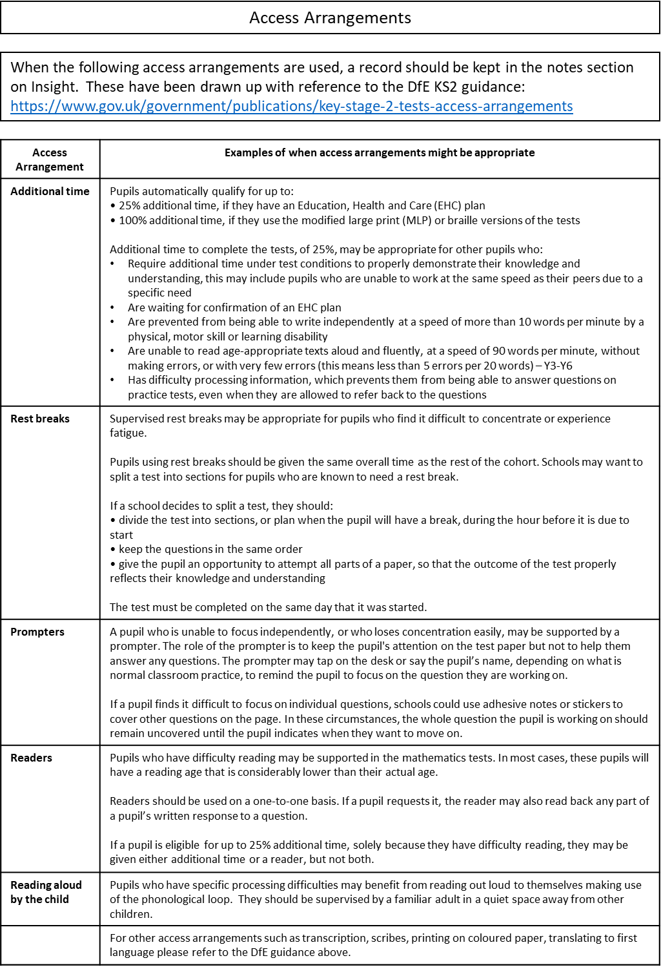
APPENDIX 2: Transform Adapted Leuven Scales


